“The master’s tools will never dismantle the mater’s house” wrote Audre Lorde an activist and poet, in an essay in 1984. Over the course of our study, we will attempt to present an overview of discrimination, particularly as it pertains to lending practices. This is not a new phenomenon nor is it a surprise to many, however, to do a project of this scale and to not do it on something worth understanding and analyzing would have been a wasted opportunity. Our goal in approaching this matter, is to objectively analyze the data in order to produce a real-world image of the condition of lending in today’s society. This is by no means to claim that this is an end all be all study, instead this is a humble venture, based on a limited data set for the state of New York in the year 2017.

In the words of the music artist Jay-Z “if you can make it here, you can make it anywhere” New York is the state of ambitious promises. New York state as a stand-alone economy is greater than the country of Canada, 3rd largest in the United States and 10th largest in the world when compared to all nations worldwide. It is home to just under 20 million people, and perhaps one of the grandest canvases of diversity seen anywhere in the world. Therefore, for the matter of this study it only seemed fitting to study New York, after all, if there is a place where a natural expectation of intolerance and purging of discrimination should exist, wont that be the place they call the melting pot.

In 1933, then President of the United States, Franklin Roosevelt created the Home Owners Loan Corporation with the goal to reduce foreclosures during the Great Depression, this further led to the establishment of Federal Housing Association in 1937. The FHA drew up governing policies that identified geographical areas unfit for investment by banks, insurance companies, savings and loans associations and other financial services institutions. Most desirable areas on these maps were colored in green while other areas that were still good for investment but not as desirable were colored blue and the least desirable area or rather the undesirable areas were marked red, makes one wonder if there was a shortage of the color yellow during this time period.

Redlining was born, and legal lending discrimination was set in motion. As a result of redlining, these neighborhoods lacked access to the same resources that helped develop and bring prosperity to other locales across the United States and yet their state of underdevelopment only further made them undesirable for investors. Small businesses could not secure loans as they were deemed high risk, leaving these communities with not only a lack of access but additionally a lack of opportunity. Curiously enough, investors were not completely hands-off in these areas, as there are several documented occasions where bars and liquor stores successfully secured financial resources for startup and operational needs.

Redlining, of course is the most blatant an example of lending discriminations and it is not just something that existed in the United States, but rather in Canada and countries around the world this was a well-documented occurrence in history. While we discuss discrimination in this study, it is imperative that we understand that race is innately involved, which is to say that redlining and policies like these have through-out history targeted African-American neighborhoods. These actions have long lasting consequences, and in the year of protests around the country, it is important to acknowledge this truth.

Without diminishing the affects of these policies on the larger African–American community in the United States, we must also recognize that a country of immigrants has the built in characteristic of shifting demographics, and while African-Americans communities still suffer from similar policies they are no longer the largest group that is facing this uphill battle. In a study done by the Brookings Institute, Latino or Hispanic individuals were found to be facing the largest segment of discriminatory lending practices like redlining in 2017.

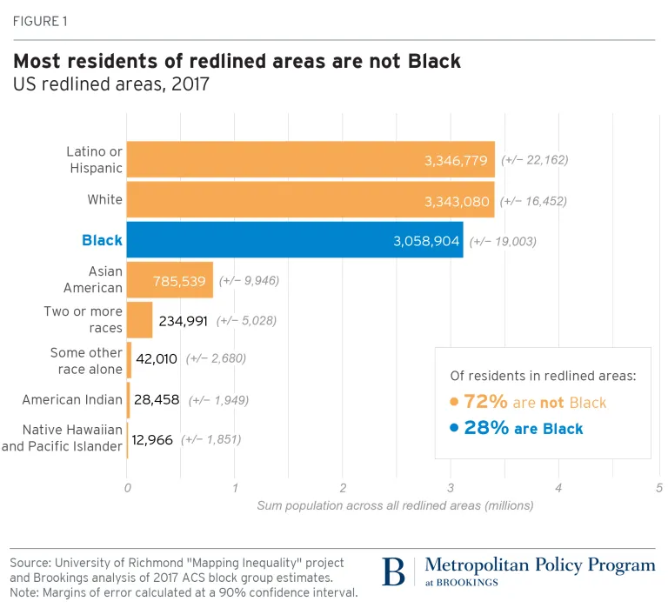

As the chart highlights, 72% of people facing the realities of redlined areas are not African-Americans, Hispanics make up the largest part of this subgroup slightly out pacing Whites. Does this prove that discrimination is no longer a concern since evidently race is not so monotonous? I’d argue no, this is if anything the evolution of discrimination, and perhaps a big red flag that should draw all of our eyes towards itself. It is true that its inception lending discrimination through policies like redlining was conceived to target particular communities while promoting other communities, but with a growth in immigration rates and the draw of the American dream our society has become more diverse and as a result today’s redlining may not see color but it continues to discriminate on your social and financial status.

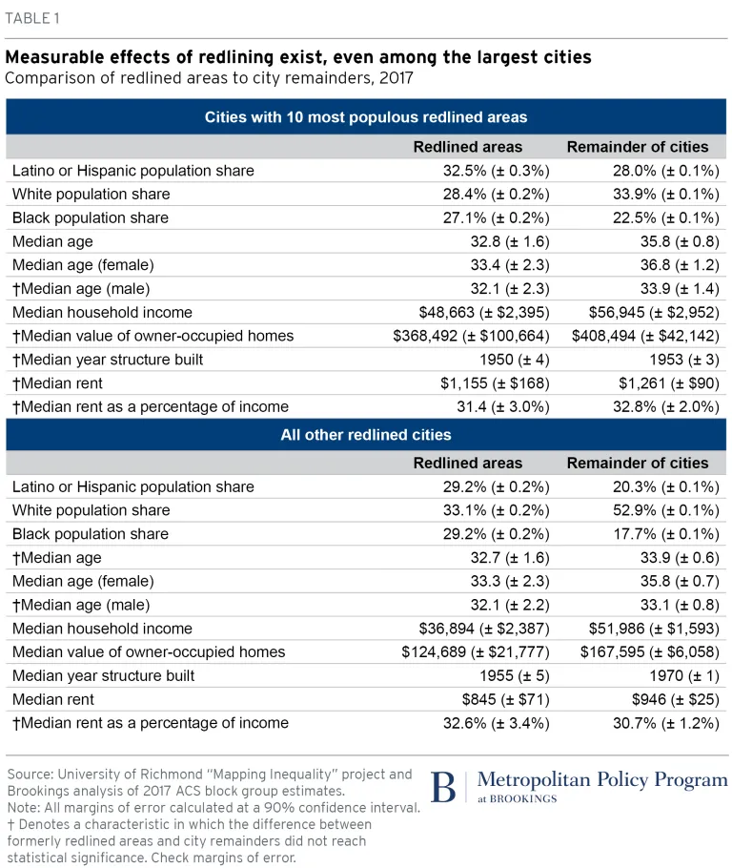

The table above helps to highlight this modern-day redlining based on an individual’s social and financial standings. It breaks the data down into two categories rather wisely, as to not let the aggregate data from large cities where numbers are likely to be inflated, influence the data from cities that are not as populous. The redlined population in big cities has a lifespan of 6 years shorter, while earning $ 8,000 less per year and living in older houses which cost barely less than those of their respective non redlined population. These variations only grow further as you get away from the big cities and take a broader perspective, as the redlined population in smaller cities is likely to have a shorter life span, earn on average $ 15,000 less, live in houses that are considerably older and spend almost 3% more of their earnings on living accommodations when compared with the non-redlined populations in those cities.

**Hypothesis**

Discrimination continues to endure in today’s lending proceedings, regardless of the laws that may have been enacted to combat this issue. We hope to establish this through analysis of the HDMA data for the years 2017. (<https://files.consumerfinance.gov/hmda-historic-loan-data/hmda_2017_ny_all-records_labels.zip>). We will focus on working through a variety of independent variables in order to observe any noticeable trends that may vary among different races, income levels and possibly even neighborhoods. Our commitment is to draw scientific conclusions based purely on the analysis of this data, and while it may seem limited, we believe that it is a good measure for the activity today due to its recency and comprehensive coverage of one of the largest states in America.

**Methodology**

The methodology surrounding our project focused on identifying whether there was a correlation between race, ethnicity, and loan approval/rejection rates. We created several regression models that focused on finding discriminatory trends in the New York State 2017 Mortgage Data Set. A linear regression is type of statistical method used to predict trends. The idea is to determine whether a set of independent variables can successfully predict our dependent variable. The outcome of this analysis is that the regression estimates can be utilized to measure the strength or the effect of the independent variables on our dependent variables. The regression can also be used to forecast the effect of each variable and determine whether there is a relationship. Lastly, the regression can be used to predict trends and future values.

We will also employ Logit and Probit models, which are used when measuring binary variables, meaning variables that have two responses. These regression indicators are usually between zero and one. The logit model uses the cumulative distribution function of the logistic distribution while the Probit model uses the cumulative distribution function of the standard normal distribution to define a function.

Lastly once we analyze the effects of our regressions on our dependent variables, we then focus on creating various prediction models to determine accuracy and feasibility. These prediction models will be used to further determine if our hypothesis is correct.

**DATA Cleaning**

We started by formulating a subset of dat3 to create a new vector called DFNA. Within this vector, we used the complete case function to remove all the NA’s in the columns of interest from dat3. In pursuit of data integrity and maximizing use of our data resource, we ensure to retain the data in rows while omitting NA’s from the columns. We choose to remove NA values for those specific columns because using imputation or predictive model to predict the missing responses would be problematic considering this is a response data which is not something particularly easy to predict using artificial values because these values can be heterogeneous. Furthermore, many of the variables are categorical and characteristics such as gender, and race cannot be generated based on other values. We are aware there could be an undesirable consequence that we may lose a substantial amount of data and thus the precision of the estimators will be lower. It should not lead to a largely biased representation, as we tried to keep the original data as intact as possible.

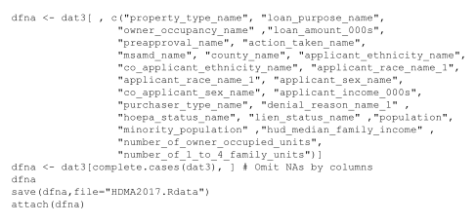

Below, we initialized the use of a package to visualize variables containing the most NA values and concluded that ‘applicant_income_000s’ has the most NA values. Apart from undesirables NA values, we also looked to utilize the former variable as a key dependent value.



To further our efforts to remove all extremities and significant outliers within ‘applicant_income_000s’ we utilized boxplots. In a boxplot, it shows us the extremities from the upper quartile as it is numerically very distant from the average mean. We chose to keep the values in the lower quartiles because the mode was significant in relation to the larger outliers and paired this with the summary function to see the leveled maximum value of 272 which was a lot closer to the mean value of 98.91.

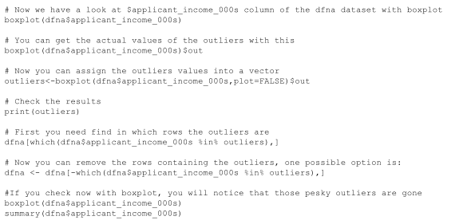

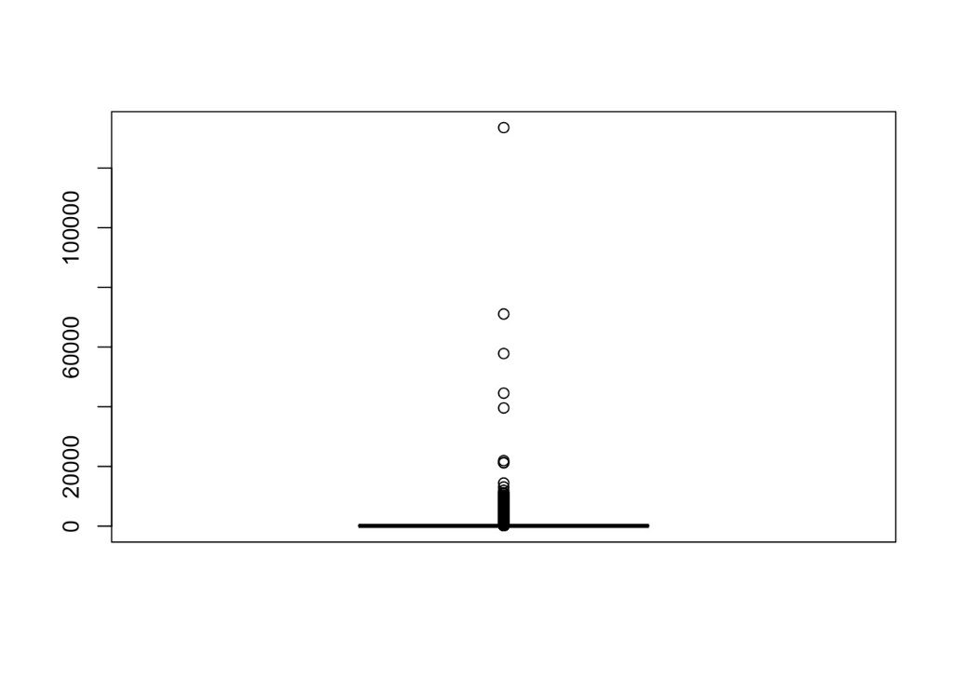

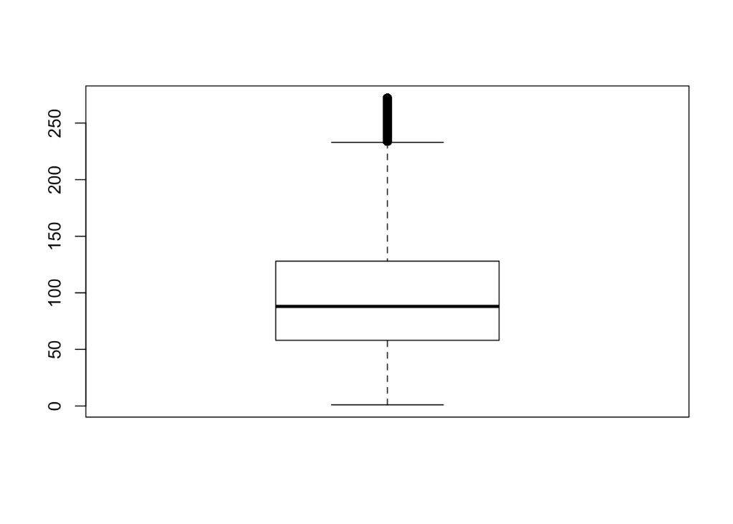

Next, we created dummy variables of interest. We identified ethnicity, race, and gender would be good predictors to determine the approval rate for an applicant. We created dummies for ‘action taken name’ and successfully created Loan Approved. We gave it a value of 1 if the person was approved for a loan and a value of 0 if the person was not approved for a loan. We repeated the process for each variable of interest. Then we wanted ‘Hispanic or Latino’ be observed along with the other races, so we merged both columns in order to differentiate between those off white and black races from White and Black races with Hispanic or Latino ethnicity. This was imperative since our dataset recognized Hispanic or Latino as an ethnicity instead of a race on its own.

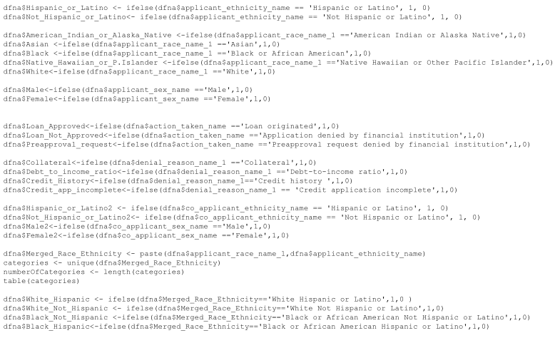

Lastly, through the application of the knit package we created a table to display the number of approvals and disapprovals for loans.

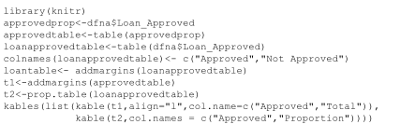

**Observations**

Observation 1 Regression for Collateral



In the data set when calculating for the probability that a participant would have their mortgage denied because of a high rate of collateral, we discovered that there was a positive correlation between participants who refinanced their mortgages vs participants who purchased a home. Re-financing might be a difficult proposition for many participants, because the large accumulation of debt from a mortgage could affect a participant’s net worth, and as a result the amount of collateral a participant would be low. It was interesting to see how participants who applied for a loan to purchase a home were less likely to face rejection than those who were re-financing. We can determine this by analyzing the high negative T-value for Home Purchasers which was -8.5, this value indicates that home purchase applicants were approved compared to the high positive T-value of 12.657 for re-financers, which indicates these individuals were denied loans in comparison. It is also interesting to note that out of all the major ethnic and racial groups, Hispanics in our dataset had a higher probability of having their loan rejected for collateral reasons.

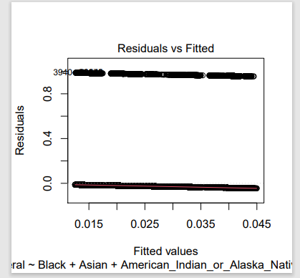

Observation 2 Regression for loan application rejected because of high Debt to Income Ratio

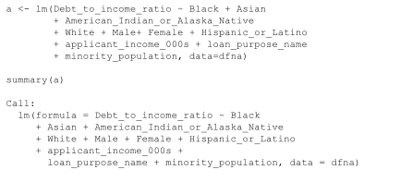

A High Debt to Income Ratio can be defined as the percentage of a consumer’s monthly gross income that goes toward paying debts. A low debt to income ratio indicates that a participant does not spend much of their income towards debt and would be categorized as less risky than a participant who spends most of their income of debt.

According to the data set, our regression indicates that among the applicants who had their application rejected because of high debt to income ratio, individuals in counties with high minority populations faced a higher rejection rate in comparison to the individuals from counties with lower minority population. We further observed that individuals were more likely to be rejected for their request if their respective T-Value was positive, meaning that if someone had a positive T-value of 1 while they were less like to be rejected for a loan than an applicant with a higher T-value, for our data set their inquiry would result in a rejection. Participants in our dataset who identified as Hispanic or Latino had a higher probability of being denied under this circumstance than other racial groups. The average T-value for Hispanic participants was 6.76, however, other participants in our data set who identified as White had the most negative coefficients among all the racial groups averaging -8.137. This negative coefficient shows that White applicants were least likely to have their application denied because of high debt to income ratio.

Using High Debt to Income Ratio as our y-value, we can see the impact of income inequality being reflected in our data set.

To verify the authenticity of our regression we added two sets of the ‘Loan_purpose’ variable: Home Purchase and Refinancing, applicants who filed for a loan to purchase a home were much more scrutinized compared to applicants who refinanced their mortgage. In terms of high debt to income ratio, a mortgage lender would most likely accept a refinancing application compared to home purchase application. If a participant has a mortgage already, they were most likely vetted by another lender and as a result it would be relatively easy to have their application approved.

We can see this pattern by analyzing the corresponding T-values. Participants who were approved to purchase a Home had a largely negative T- value of -59.45 compared to participants who successfully refinanced had a negative T- value of -37.016.

Participants who had their applications rejected because of an incomplete credit application most likely identified as Hispanic or Latino. According to our regression Hispanics or Latinos had a positive coefficient 3.

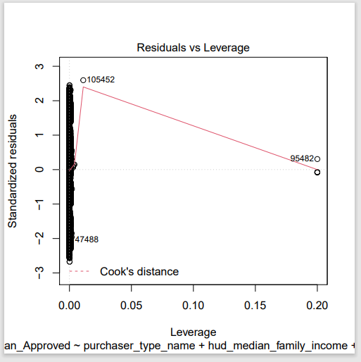

Observation 3 Regression for loan application rejected because of Credit App Incomplete

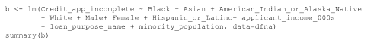

We observed that the participants with the highest coefficient value resulted in an Incomplete rejection to a Credit App. Most of these applicants were participants who had lower incomes. This relationship is not necessarily based less on ethnicity and race, instead the focused variable was on applicant income. The coefficient variable for applicant income was the second highest in our regression that measured rejection rates for incomplete applications. The refinancing process is full of fees and closing costs, therefore it would make sense that participants who had either lower incomes and were considering re-financing might have credit issues or upon realizing the true cost of re-financing their mortgage, participants would have just stopped providing documents all together. Overall, it seems that income plays a re-occurring role during the loan approval process. This regression did not highlight any relationship between race & ethnicity, and loan rejection rates, but it addressed the difficulties endured by individuals trying to re-finance their mortgages.

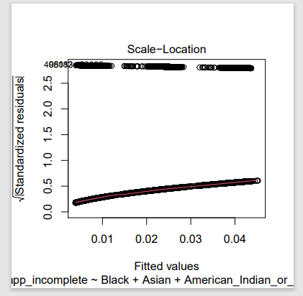

Observation 4 Regression for Purchaser Type

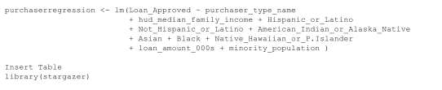

We created a regression that looked at loan approval ratings that included several important variables used by banks in the loan approval process. We ran this regression to model a relationship between the loan originators, which are Fannie Mae (FNMA), Farmer Mac (FAMC, Freddie Mac (FHLMC) and Ginnie Mac (GNMA).

All variables in our regression were statistically significant at the 90 and 95 percent confidence interval except for certain participants who enrolled through the Farmer Mac loan program. The variables with the highest positive T-values were correlated with a positive response on the participant’s loan application. It was surprising that participants who enrolled under the Ginnie Mae program had a negative T value of -11.729.

The Ginnie Mae Program stands for the government national mortgage association they guarantee mortgage-backed securities to individuals that are a part of the FHA - Federal Housing Administration, VA - Veterans Affairs, PIH - Office of Public and Indian Housing. Fannie Mae and Freddie Mac on the other hand are conventional mortgage loans that deal with private or commercial lending. Therefore, it seems that participants who filed under a Ginnie Mae Program are less likely to have their loan approved by a mortgage lender. This could indicate that mortgage lenders prefer participants who are not associated with government programs. Perhaps mortgage lenders might associate public programs with higher debt to income ratios and therefore these programs might provide more risk. It is important to note that the Ginnie Mac Programs are insured by the Federal Government.

The Farmer Mac Program is a public subsidized lender to farmers and ranchers throughout rural America. Participants who had applied under the Farmer MAC program did not influence our regression. These participants were not statistically significant, our guess is that this is most likely due to the number of farmers within New York State is relatively low. As a result, the number of participants who applied under the Farmer MAC program did alter the direction of our regression.

When looking at the purchaser types of all the possible selections, mortgage lenders preferred lending to commercial banks, savings banks, or other financial companies. The T-values for purchaser types that consisted of commercial and savings banks as well as finance companies had a positive t-value of 20. These large financial institutions are typically audited and have a clear stream of income. Therefore, mortgage lenders view loans to other financial companies as a low-risk endeavor.

Another important outcome from this regression was the relatively large negative t-statistic for the variable: ‘minority population’ The minority population variable in our dataset is an index showing the percentage of the county’s population within a particular county that would identify as being a person of color. The minority population index is between 1 and 100. The minority population variable had a negative t-statistic of 54.48. Among all of the variables in our regression, the minority population had the overall largest negative variable. This is incredibly insightful because the negative T-statistic allows us to infer that counties with high minority population densities have less mortgage approval rates than counties with smaller minority population densities.

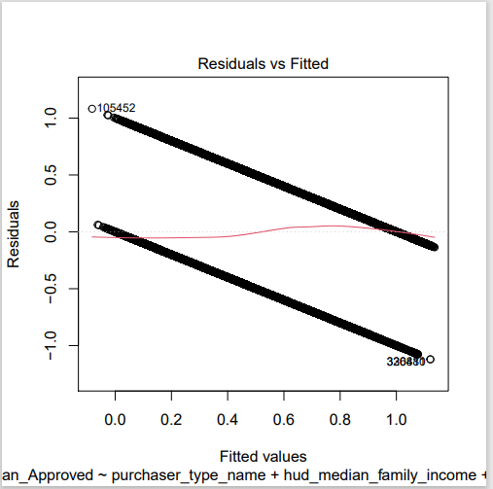

Observation 5 Studying Income in our datasets and it is racial and gender implications

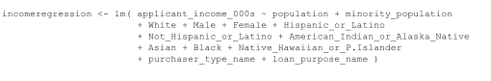

Income is an important part of the loan approval process; it can affect the type of home a participant can be eligible for; as well as whether a participant would be denied for having too high of a debt-to-income ratio. We ran a regression where applicant income was the dependent variable while race, ethnicity and loan purchaser type were independent variables. We wanted to determine which variables contributed the most to the direction of our regression line.

According to the data set, participants that were either Hispanic, Black or American Indian/Alaska Native had negative T-Values ranging from -11 to -20. These negative values indicate that these participants had less than the median income in our data set, pulling the regression in a negative direction. These values also tell us that participants who were minorities had a higher probability of having their application rejected for not having a high income-to-debt ratio, meaning these participants could not meet their mortgage payments. These T-values indicate that income inequality still exists and has influenced the mortgage process. Income is incredibly important, and the lack of income has many implications for home buying process such as neighborhoods that people can live in, types of schools that one can attend, and even the types of services that are readily accessible.

Another important correlation that our regression identified was the gender pay gap within the United States. The Male variable had a positive coefficient of 17 which was one of the top individual variables in our regression. However, Females had a negative coefficient of -9, indicating that the gender pay gap had influenced the mortgage approval process. According to a report on PayScale the uncontrolled gender pay gap that measured the median salary for men and all women was 81 cents, meaning women earn 81 cents for every 1.00 dollar earned by men. The higher coefficient for men highlights the fact that men are most likely more represented in our data set compared to women. Sadly, the gender gap has changed the gender composition of our data set.

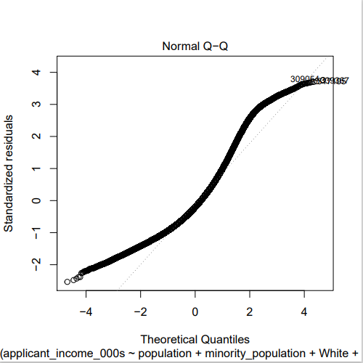

**Analysis**

Analysis 1 Loan Approval For White & Black Hispanics by County

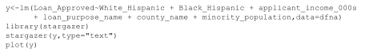

In this model, we took an observation of Hispanics by County. We resulted with that counties are not statistically significant because both the T statistic, and coefficient are small. Someone who is white and of Hispanic ethnic background is more likely to be approved for a loan than someone who is Black and of Hispanic ethnic background.

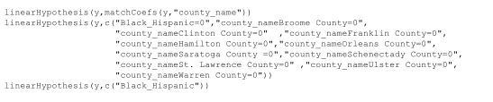

Using ‘car package’ we performed F-Tests to validate if the variables were jointly statistically significant, but we found this not to be the case in this scenario.

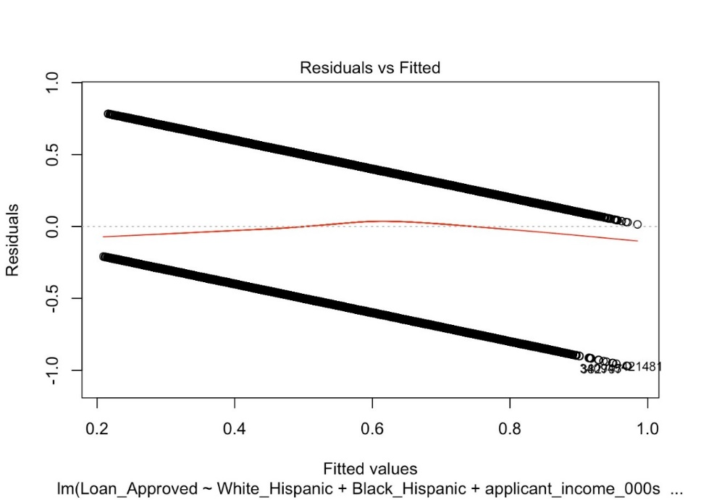

Analysis 2 Loan Approval for White Hispanics & White by County

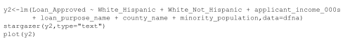

We took out Black Hispanics because it was not statistically significant. We see the same counties from the prior regression are statistically significant, but some have increased coefficients. Here we see, someone who is White and not of Hispanic background is more likely to be approved for a loan than someone.

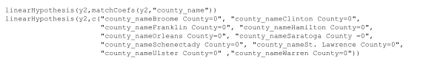

Using ‘car package’ we performed F-Tests to validate if the variables were jointly statistically significant, but we found this not to be the case in this scenario.

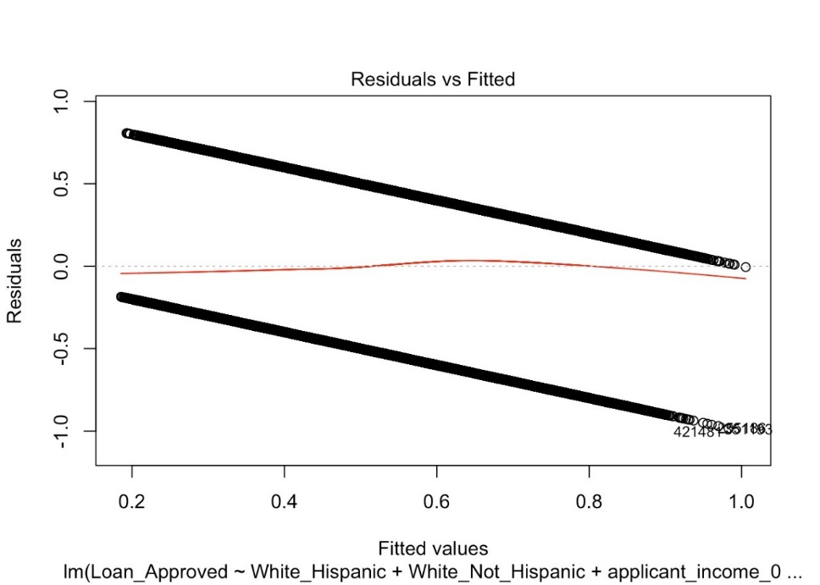

Analysis 3 Loan Approval for Black Hispanics & Black by County



Observing the difference between Black Hispanics and Black on Loan Approval Rates. Black Hispanics are not statistically significant while Blacks are statistically significant with 90% confidence.

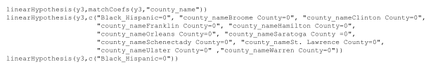

Using ‘car package’ we performed F-Tests to validate if the variables were jointly statistically significant, but we found this not to be the case in this scenario.

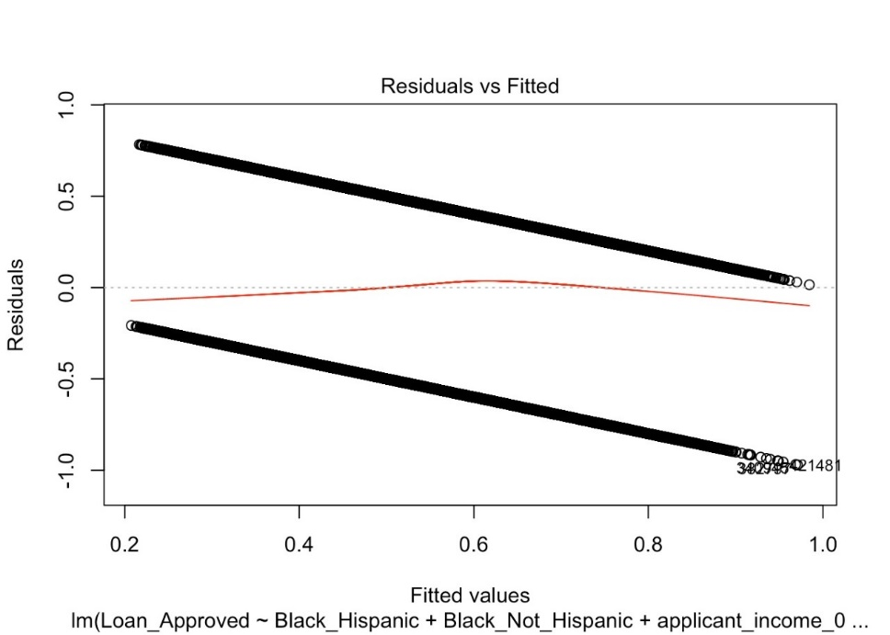

Analysis 4 Loan Approval for Blacks by County



The loan approval for Blacks is statistically significant with 90% confidence.

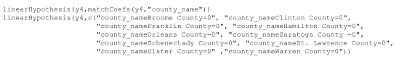

Using ‘car package’ we performed F-Tests to validate if the variables were jointly statistically significant, but we found this not to be the case in this scenario.

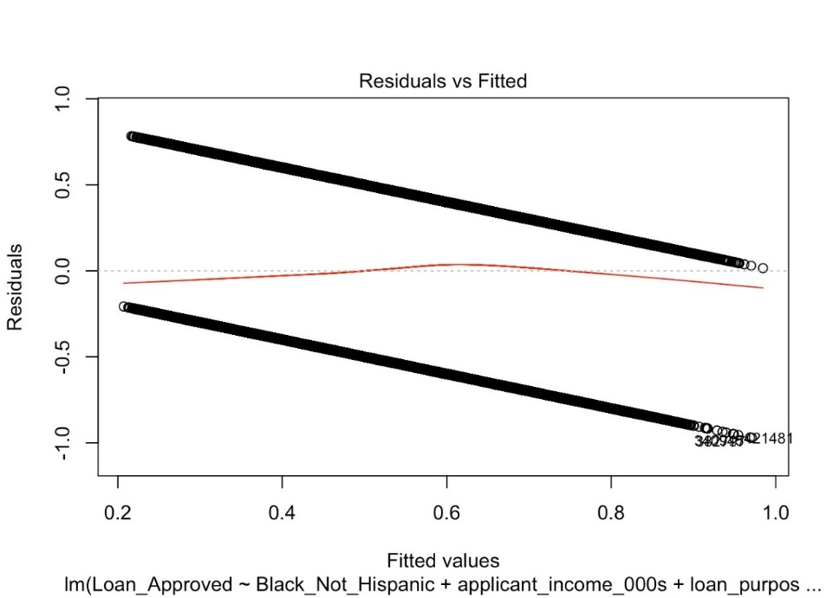

Analysis 5 Loan Approval by Applicant Gender



We compared Male and Female and found that both are statistically significant with 99% confidence. The results of this regression show that someone who is Female is more likely to be approved for a loan than someone who is Male.

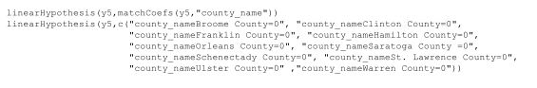

Using ‘car package’ we performed F-Tests to validate if the variables were jointly statistically significant, but we found this not to be the case in this scenario.

Analysis 6 Loan Approval by Co-Applicant Gender



In addition to Model 10 we tested co-applicant gender to draw further conclusions about the role gender plays in loan approval. Both values are statistically significant with 99% confidence. Once again, we resulted in a Female being more likely to be approved for a loan when compared to someone who is a Male.

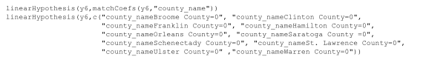

Using ‘car package’ we performed F-Tests to validate if the variables were jointly statistically significant, but we found this not to be the case in this scenario.

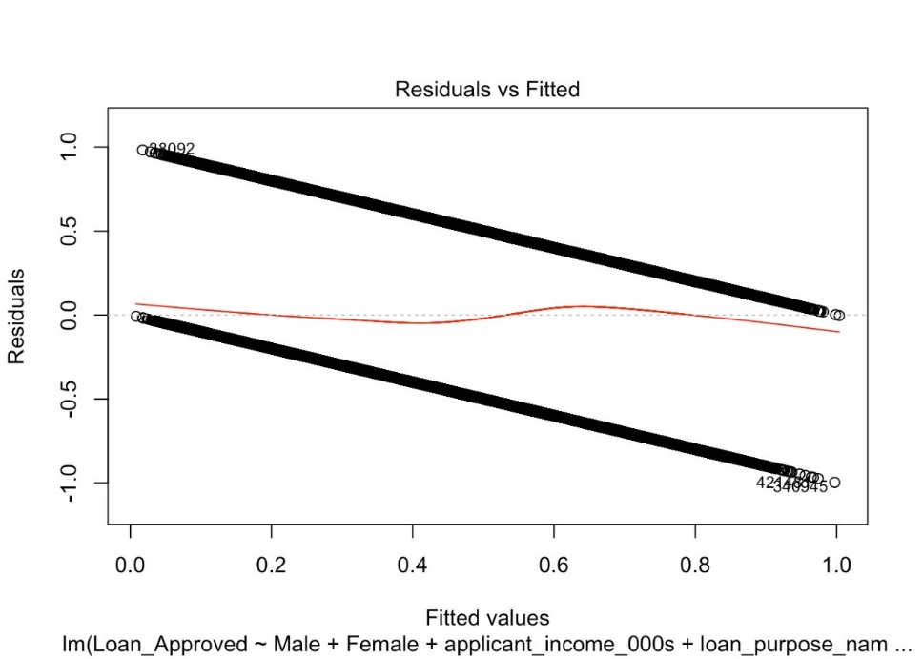

Analysis 7 Loan Approval by Income

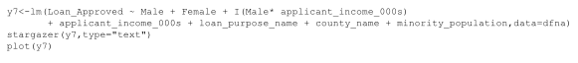

In this regression, we look at Male and Female applicants. Our results indicate that Male applicants have a greater coefficient than Female suggesting Males are likely to be approved. The interaction term shows Male and Female both influence the Loan Approval rate.

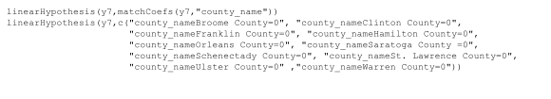

Using ‘car package’ we performed F-Tests to validate if the variables were jointly statistically significant, but we found this not to be the case in this scenario.

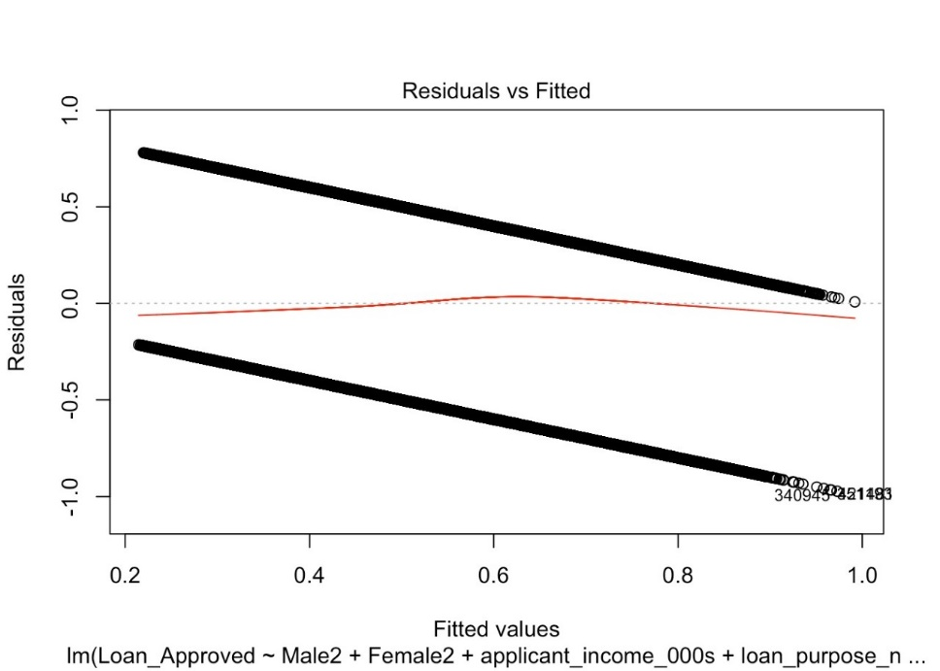

Analysis 8 Loan Approval for Minority Population

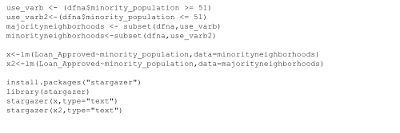

We created two subsets using the minority population variable to see if it influences the dependent variable, Loan Approved. In the neighborhood with a larger White population, they are more likely to get approved for a Loan when compared to a neighborhood with a high percentage of Minority Population. Both values are statistically significant.

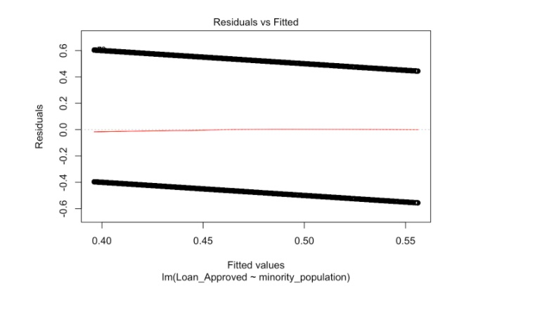

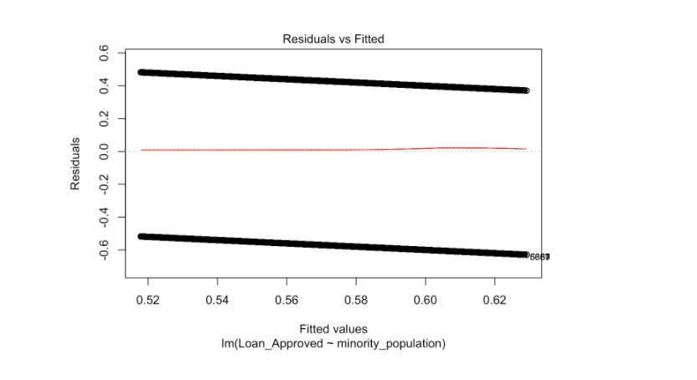

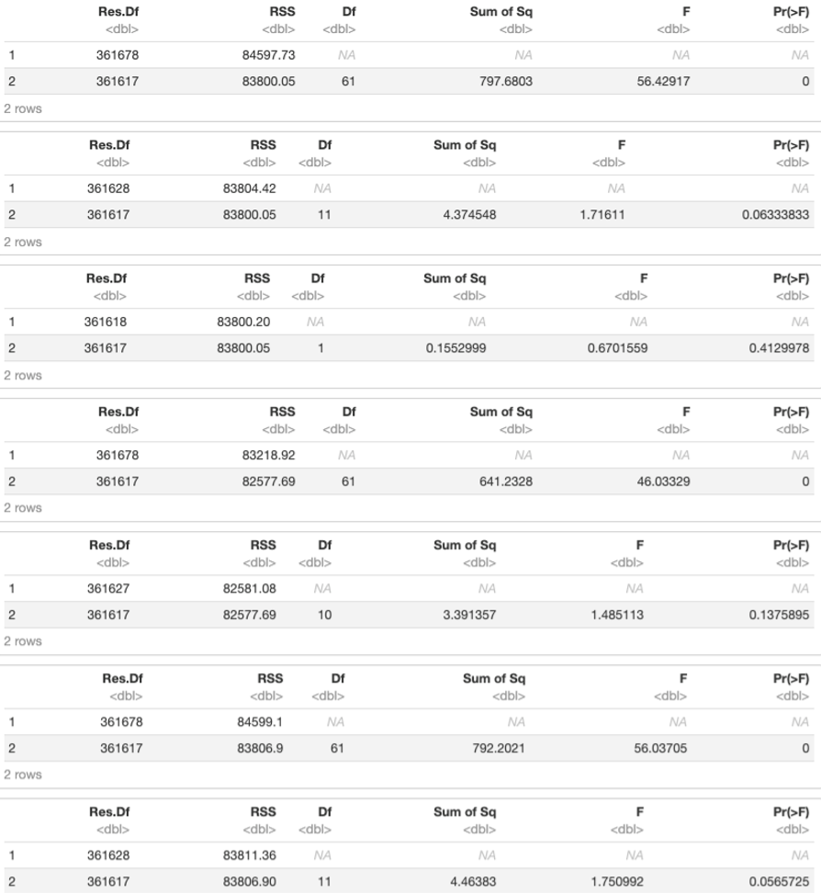

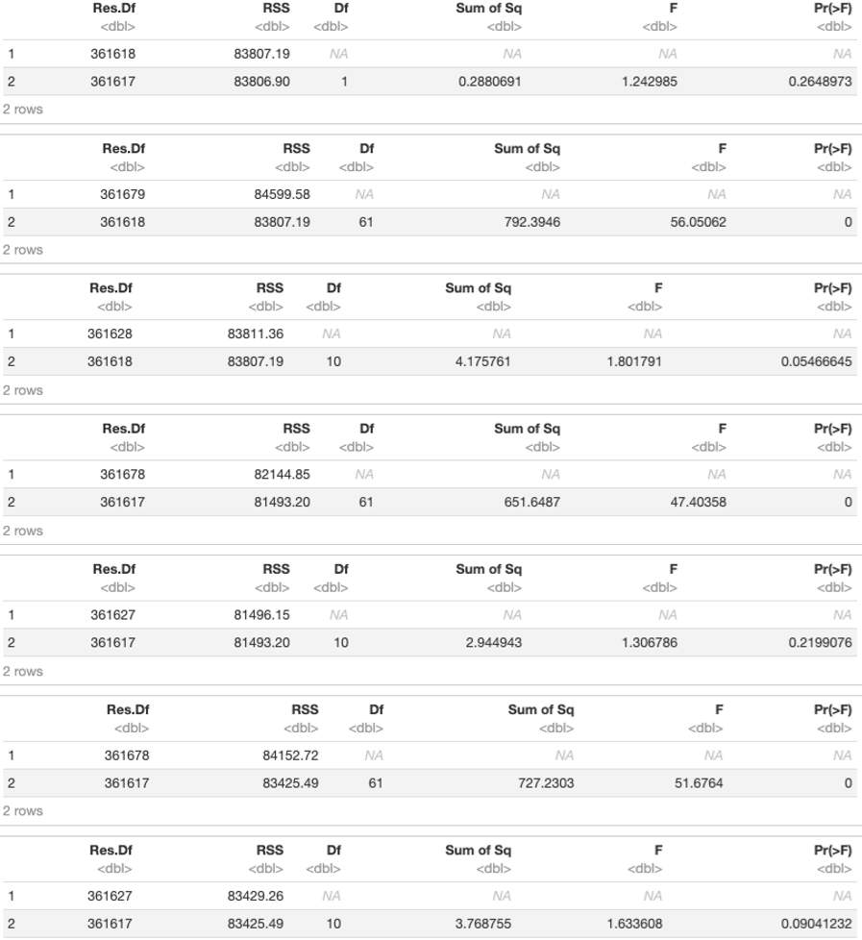

Closer look

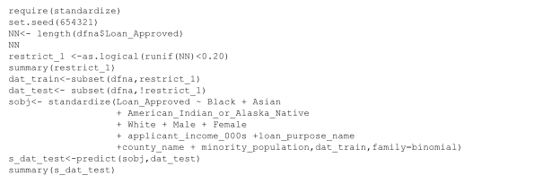

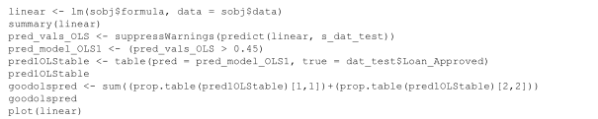

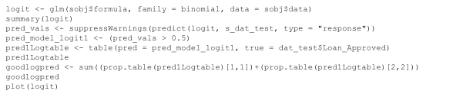

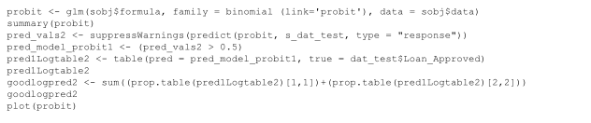

We utilized the provided data frame and standardizing code to standardize the variables and create training and test sets. The training sets are comprised of 20% of the total observations. Standardizing allows us to compare all the variables, so there is no bias because one variable as it may contain more weight than the other variables, simply due to the difference in natural units. Example, income and population have relatively large amount of data in comparison to the dummy variables, whose values contain either 1 or 0.

Given the standardized variables, we compared the OLS and Logit regressions. While the values of each coefficient varied, the sign for each coefficient remained the same across both regressions. The OLS regression therefore demonstrated that the correlation of each variable with the condition of the loan approval meaning the logit regression provided us the probability of the condition of loan approval, given each variable.

As aforementioned, due to the standardization of the variables done above, the coefficients estimated by the OLS regression are all small – if we consider them as raw values, which would provide us a skewed interpretation of the results; we need to consider these absolute values of the coefficients with respect to the interval [0,1].

Therefore the logit regression is more straightforward, as we would expect the probabilities to be given on a [0,1] interval.

By Altering the Predvals parameter to greater than 0.45, it increases the accuracy of our models, by 0.3% and 0.11% for the OLS and Logit models, respectively. The increases are negligible. Leaving the Logit predvals value at greater than 0.5 makes more sense as 0.5 is a probability value in this model. Setting it to a value below 0.5 would skew the correct prediction rate of whether the dependent variable is equal to 1.

The prediction rate results were as follows, OLS 63.4%, Probit 64.31%, and Logit 64.32%.

**Conclusion**

“We are tired of living in rat-infested slums … Now is the time to make real the promises of democracy. Now is the time to open the doors of opportunity to all of God’s children” Dr Martin Luther King. Meghan M O’Niel in her paper ‘Housing Policy, Race, Inequality, and Disparate Impact’, carried out one of the most thorough analysis of the mortgages available across the top 100 big cities in the United States. Her research considered a data set expanding to over a million mortgages. She focused this study on the distribution of credit by race of the applicant and the racial composition of the neighborhood they were a resident off. She stated that her examination draws the conclusion that institutions are involved in a variety of violations with regards to the Fair Housing Act. Her studies further suggest that there is an unequal balance of credit distribution when we look at women, particularly single-mother households as she highlights that individuals in neighborhoods with a higher single-mother proportion of households are less likely to have access at the same rate as an individual in a neighborhood with two parent families would have. Furthermore, she states that while gaps of credit distribution have narrowed for minority neighborhood when compared historically, they remain overwhelmingly undercapitalized. In her study, like ours, minorities were found to be less likely to originate mortgages, however she goes further than our study in trying to be more conclusive by looking at the difference between minority individuals with the same financial status, assimilation profile, demographic grouping, and housing characteristics to still shockingly produce the conclusion that the minority individual was less likely to be approved. She claims to be distraught by this being the reality fifty years after the passage of the Fair Housing Act and concluded that just being a minority seemed to be the cause for mortgage denial as she claims to have not discovered any plausible correlation otherwise.

In October 2011, The Journal of Money, Credit and Banking published an article called “Race, Ethnicity, and Credit Card Marketing” by Simon Firestone. In this article the author discusses his study which was focused on lending discriminations based on the premise of race. He notes that in an earlier study done Blacks were roughly 27% less likely and Hispanics were 17% less likely to receive offers from a lender during a sample period even when you account for controls like credit history, household income and local economics conditions. Simon claims that while many factors are involved, educating the consumer through marketing about the offers a bank may have is partly responsible. Author further establishes his claim by reviewing the Survey of Consumer Finances from 2010 which informs us that while 42% of Black house-holds and 44% of Hispanic households have at least one credit card, an astonishing 72% of White house-holds have at least one credit card. The author frames these results in the social context to say that this sort of unequal access (or as we have framed this, lending discrimination) has real world social consequences as these minorities are more likely to utilize more expensive lending tools available like payday lending when there is a lack of access to better lending solutions. Tools like payday lending only furthers the negative impact on their ability to accumulate wealth and additionally hurts these individual’s overall economic ability.

In the paper “Lending Discrimination Claims and the Issue of Redlining: Analysis of Lending Patterns for An Individual Institution”, the authors Andrew Holmes and Paul Horvitz carry out their study on lending discriminations based on HMDA data. They claim that according to the data, the financial institutions made most of their mortgage and home improvement loans in predominantly white neighborhoods. In their data table 1, they show key figures to help understand the extent of redlining, according to the data a neighborhood that is 0% to 24% black is 9 times more likely to receive conventional mortgages than a neighborhood that is 75% to 100% black, similarly the former neighborhood is 6 times and 4 times more likely to receive refinancing loans and home improvement loans respectively when compared to the latter neighborhood.

The results from our study implicitly make the case for discriminatory lending practices towards people of Black Race and Hispanic Ethnicity. They have lower probabilities for loan approval, which result in the assumption that there is inequity in property ownership for minorities. Furthermore, many pervasive issues like income inequality amongst participants of various racial groups are readily apparent in our data set. In order to achieve a universal brother and sisterhood more must be done by communities and

governments to reduce wealth inequality and ultimately promote fair and equitable homeownership

Through our analysis, again and again we found ourselves in a self-fulfilling prophecy with regards to our hypothesis. Time and time again doubt arose, but through it all we discovered discrimination was easily observable in our system. We have had regulations, and the fair housing laws to protect and enable our struggling class, yet it seems that in a systematic way with support of laws our institutions have configured a method in which they continue to discriminate. Admittingly, this discrimination is not as black and white, nor is it that grey, clearly as America has evolved so has the ways we discriminate and those that we discriminate against. However, it is imperative to acknowledge that minorities by far are the victims of these unconscionable lending practices which are enabled through characteristics like lower wages, high debt caused by lower wages in turn enabling institutions to label these minorities as high-risk prospects therefore denying them access to the finances that can enable them to even the playing field in order to catch up with the more fortunate in our society.

**References**

* Firestone, Simon. “Race, Ethnicity and Credit Card Marketing.” *Journal of Money, Credit and Banking*, Wiley, Sept. 2014.
* HMDA. “Mortgage Data.” *Consumer Finance*, 2017, https://files.consumerfinance.gov/hmda-historic-loan-data/hmda_2017_ny_all-records_labels.zip.
* Holmes, Andrew, and Paul Horvitz. “Lending Discrimination Claims and the Issue of Redlining: Analysis of Lending Patterns for an Individual Institution.” *Journal of Forensic Economics*, National Association of Forensic Economics, 1997.
* O’Neil, Meghan. “Housing Policy, Race, Inequality, and Disparate Impact.” *Phylon*, Clark Atlanta University, 2018.